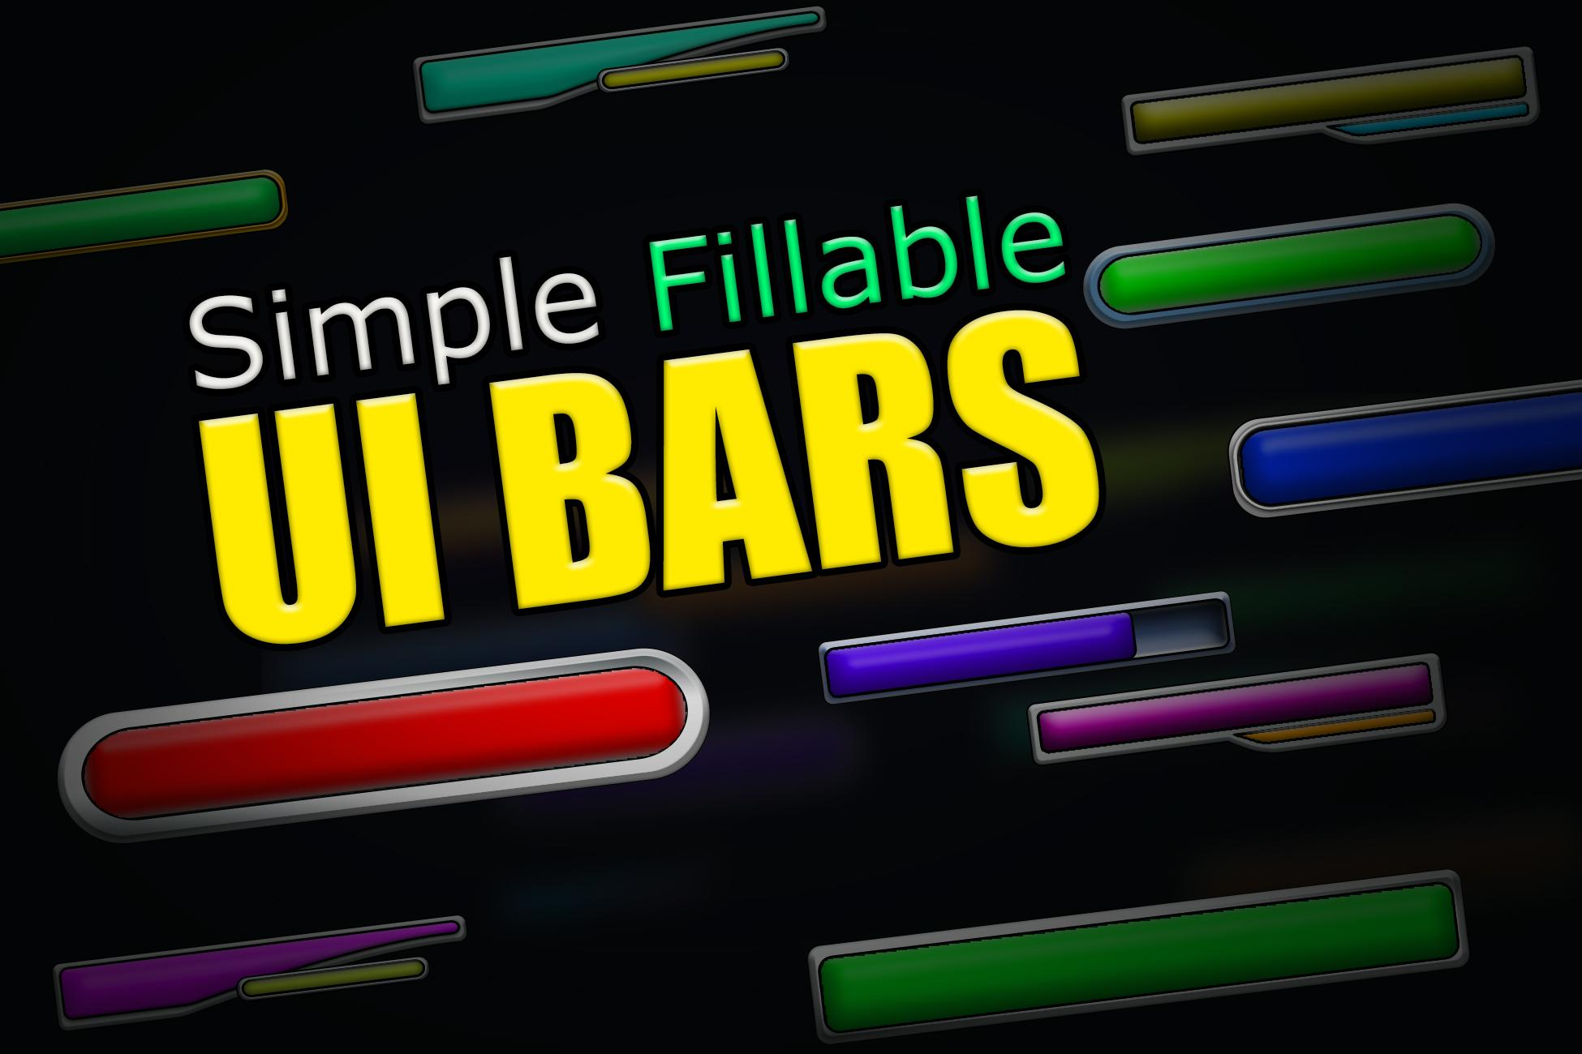

TeenZombie Unity Assets:
Simple Fillable UI Bars
Version 1.0, August 10th. 2020

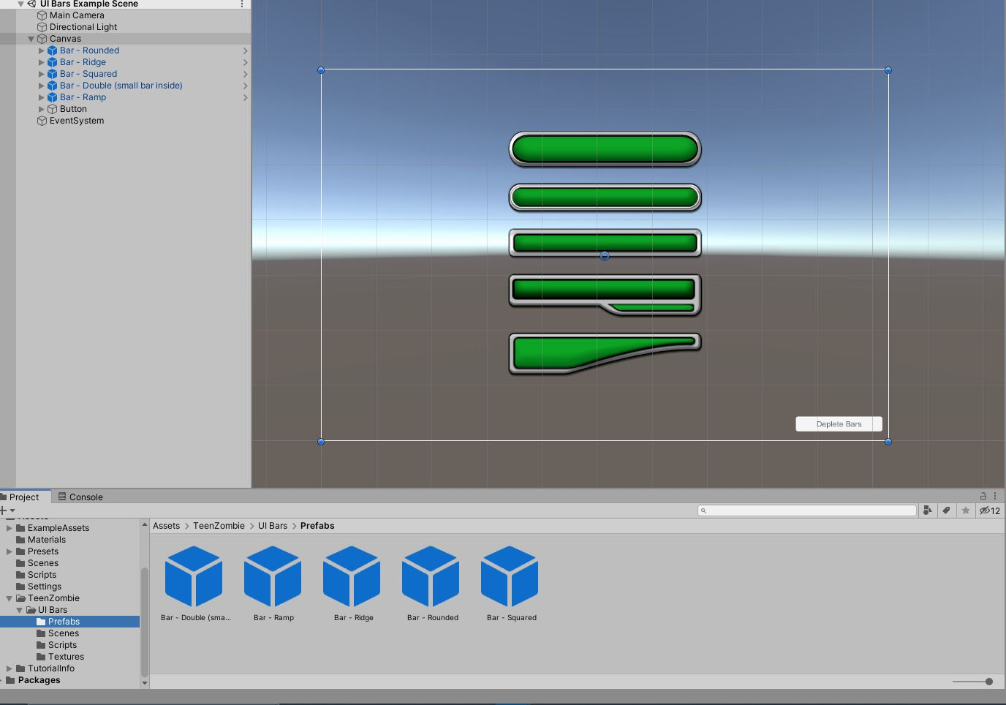

Example Scene:
The example scene contains several UI bar prefabs within a canvas. A button is located on the bottom right of the canvas. It is linked to the prefabs and setup to call their TrySpendFill() function on click.

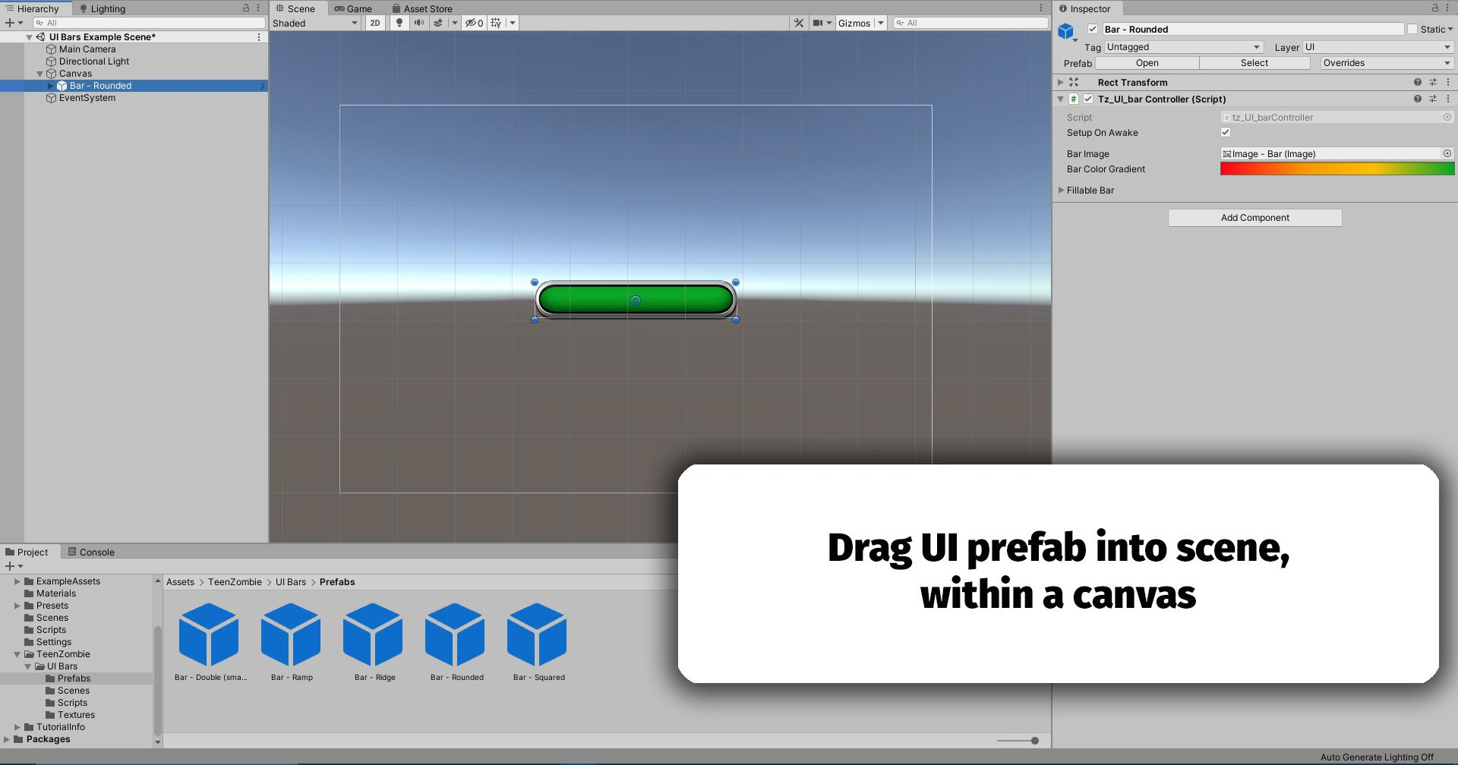

Basic Setup (default values):
1: Select a UI Bar prefab and drag it into the scene, and into a Canvas element.
2: Position the bar as intended for your particular use.

Setup (non-default values):
(Setting up the bar to startup with different values than default)

1: Select a UI Bar prefab and drag it into the scene, and into a Canvas element.
2: Position the bar as intended for your particular use.
3: With the bar selected view the Inspector window, locate the Tz_UI_BarController component.
4: Within that component, open the ‘Fillable Bar’ dropdown, which will expose several variables to allow customization. View the Fillable Var Breakdown for an explanation of these variables.

Adjusting Bar Color:

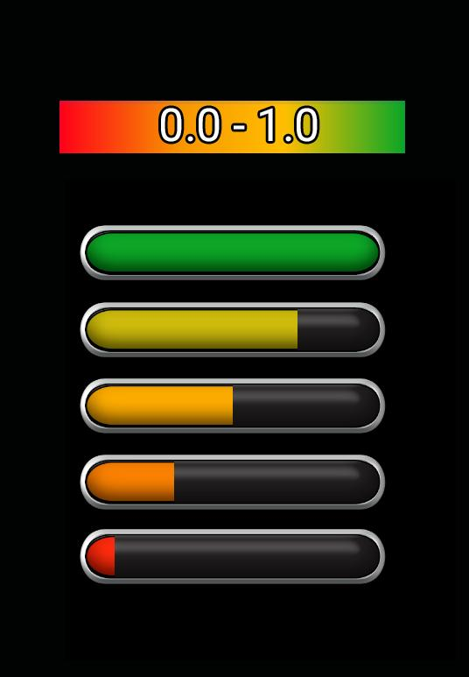 | To adjust the bar color, change the Gradient Color located in the Tz_UI_BarController component.  *Note* Gradient corresponds to the fill amount. Fill adjustment may be needed to check gradient colors.

Fillable Variable Breakdown:
MAX_FILL (int):
-Allows UI to process values greater than 1.0. Example: Player has 420 health.
-Default of -1 will result in a MAX_FILL of 100.
- If not set as Default (-1), value will be used as MAX_FILL’s “startup value”

Fill Amount (float):
-The Current Amount of bar fill.
-Default of -0.001f will result in a fill of 0.
- If not set as Default (-0.001f), value will be used as Fill amount’s “startup value”

CanRegenerate (boolean):
-Toggles on/off ability to regen fill when lower than 100%

Fill Regen Amount (float):
-When bar is not 100% full, if canRegenerate bool is true this amount will be added to
the fill amount ‘x’ per second.
-Default of -0.001f will result in a fill of 0.
- If not set as Default (-0.001f), value will be used as Regen’s “startup value”

Flash Threshold (float):
- When the fill amount is below this amount, the bar color will alternate between intended color and a darkened version, to alert users.
-Default of -0.001f will result in a fill of 0.3f.
- If not set as Default (-0.001f), value will be used as Flash’s “startup value”

Public Accessible Functions:
TrySpendFill(int amountToSpend):
-Tries to deplete the current fill. Takes an Int representing Amount to attempt removing from current fill

AdjustMAXFILL(int NewMaxAmount):
-Sets the MAXFILL to provided newMaxAmount;

AllowFillRegen(bool onOff);
-Toggles the ability to regenerate on and off using a boolean value

AdjustFillRegen(float newRegenAmount):
-Sets the RegenAmount to provided newRegenAmount;

AdjustFlashThreshold(float newFlashThreshold);
-Set a new flashing threshold, via newFlashThreshold, below which the bar color will flash.

GetNormalized();
-Returns the current fill / MaxFIll (useful for game calculations)

Important Notes:
1: UI bar must be inside a canvas to work
2: 9-sliced setup is Forgiving, not Infallible
3: The prefab “Double Bar” currently uses Two Tz_UI_BarController components. One is located on the element’s root, and the other within the element, on its “Small Container”.

